

Student´s Name: | TAHIR NOOR

Registration No: | 2025-CYS-170

Section: | CYS(C) Morning

Subject: | OOP(Lab)  Labs 5 - 10

DEPARTMENT: Cyber Security
D University Of Engineering and Technology ,Lahore

O

U

LAB Tasks REPORT
Lab5:
Task a:
Create a class student and display Roll no and Name.
public class Student {
int rollNo;
String name;
public int getRollNo() {
return rollNo;
}
public void setRollNo(int rollNo) {
this.rollNo = rollNo;
}
public String getName() {
return name;
}
public void setName(String name) {
this.name = name;
}
Student(int rollNo, String name) {
this.rollNo=rollNo;
this.name=name;
}
void display() {
System.out.println("Roll No: " + rollNo);
System.out.println("Name: " + name);}
public static void main(String[] args) {
Student s = new Student(1, "Ali");
s.display();
System.out.println();
}
}
OutPut:

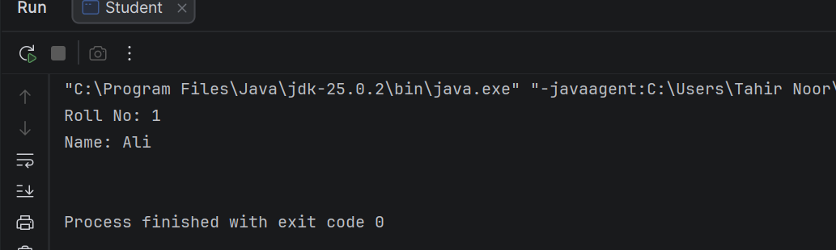
Task b:
Create a parent class animal and extends it with a child class.
abstract class animal {
abstract void sound(); {
System.out.println("animal is eating");
}
}
class dog extends animal{
void sound(){
System.out.println("dog is barking now");
}
}
class main{
static void main(String[] args) {
dog a = new dog();
a.sound();
}
}
OutPut:
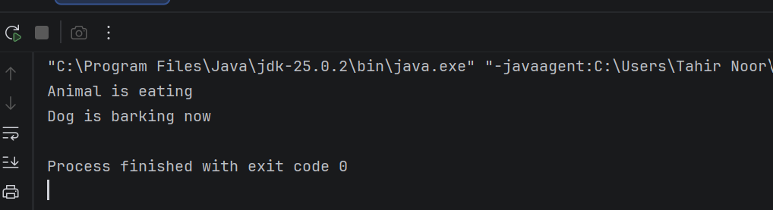
Task c:
Create a file .
import java.io.File;
import java.io.FileWriter;
import java.io.FileReader;
import java.io.BufferedReader;
import java.util.Scanner;

public class Task2 {
public static void main(String[] args) {
try {
File file = new File("myfile.txt");
if (file.createNewFile()) {
System.out.println("File created successfully: " + file.getName());
} else {
System.out.println("File already exists.");
}
FileWriter writer = new FileWriter(file);
writer.write("Hello World");
writer.close();
System.out.println("Data written to file.");
FileReader reader = new FileReader(file);
Scanner read = new Scanner(reader);
System.out.println("Reading data from file:");
read.close();
} catch (Exception e) {
System.out.println("An error occurred.");
e.printStackTrace();
}
}
}
OutPut:

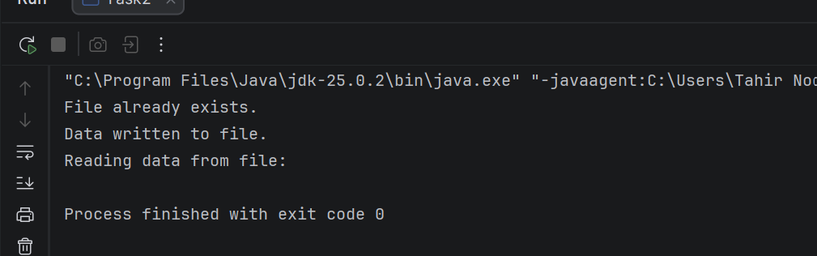

LAB 6
Task a:
Create a file and add students marks, name , roll no, and grades.
import java.io.File;
import java.io.IOException;
import java.util.Scanner;

public class Newfile {

public static void main(String[] args) throws IOException {

File file = new File("Student1.csv");
Scanner Sc = new Scanner(file);

if (Sc.hasNextLine()) {
Sc.nextLine();
}

while (Sc.hasNextLine()) {

String line = Sc.nextLine();

String data[] = line.split(",");

String name = data[0];
int rollNo = Integer.parseInt(data[1]);
double obtainedMarks = Double.parseDouble(data[2]);
double totalMarks = Double.parseDouble(data[3]);

double percentage = (obtainedMarks / totalMarks) * 100;

String grade;

if (percentage >= 90) {
grade = "A+";
} else if (percentage >= 80) {
grade = "A";
} else if (percentage >= 70) {
grade = "B";
} else if (percentage >= 60) {
grade = "C";
} else if (percentage >= 50) {
grade = "D";
} else {
grade = "F";
}

System.out.println("Name: " + name);
System.out.println("Roll No: " + rollNo);
System.out.println("Obtained Marks: " + obtainedMarks);
System.out.println("Total Marks: " + totalMarks);
System.out.println("Percentage: " + percentage + "%");
System.out.println("Grade: " + grade);
System.out.println();
}

System.out.println("Done");
}
}
OutPut:
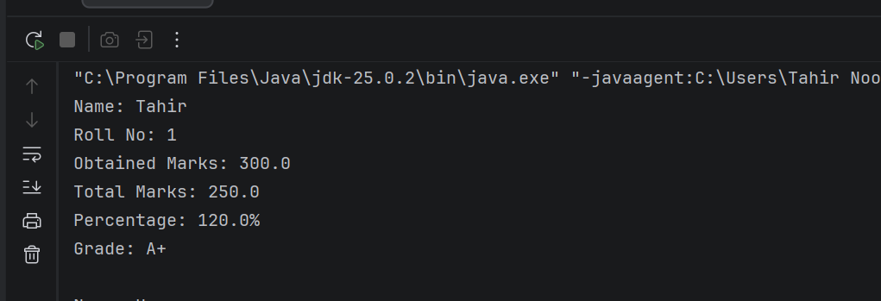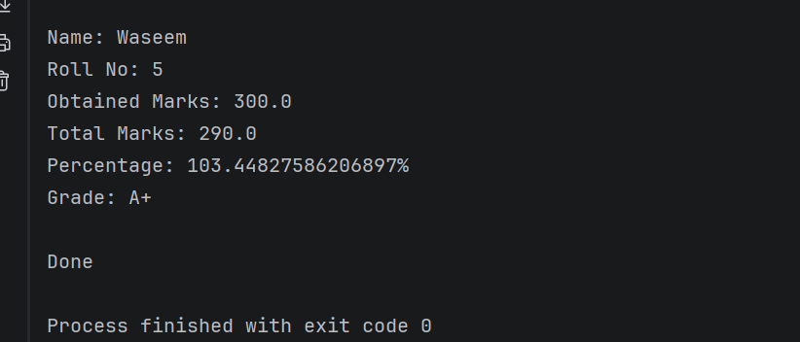

LAB 7
Task a:
Create a class bank and enter methods to add money,withdraw money , show balance and exit.
import java.util.Scanner;
class Account
{
double amount;
public Account(double amount)
{
this.amount = amount;
}
void addMoney(double money)
{
if (money > 0)
{
amount += money;
System.out.println("Money Added Successfully!");
} else
{
System.out.println("Invalid Amount!");
}
}
void takeMoney(double money)
{
if (money <= amount)
{
amount -= money;
System.out.println("Money Withdrawn Successfully!");
} else
{
System.out.println("Not Enough Balance!");
}
}
void showAmount()
{
System.out.println("Available Balance: " + amount);
}
}
public class Bank {
public static void main(String[] args) {
Scanner input = new Scanner(System.in);
System.out.print("Enter Starting Balance: ");
double startAmount = input.nextDouble();
Account user = new Account(startAmount);
int option;
do {
System.out.println("Menu");
System.out.println("1. Add Money");
System.out.println("2. Withdraw Money");
System.out.println("3. Show Balance");
System.out.println("4. Exit");
System.out.print("Choose Option: ");
option = input.nextInt();
switch (option)
{
case 1:
System.out.print("Enter Amount to Add: ");
double add = input.nextDouble();
user.addMoney(add);
break;
case 2:
System.out.print("Enter Amount to Withdraw: ");
double withdraw = input.nextDouble();
user.takeMoney(withdraw);
break;
case 3:
user.showAmount();
break;
case 4:
System.out.println("Program Closed!");
break;
default:
System.out.println("Wrong Choice!");
}
}
while (option != 4);
input.close();
}
}

OutPut:

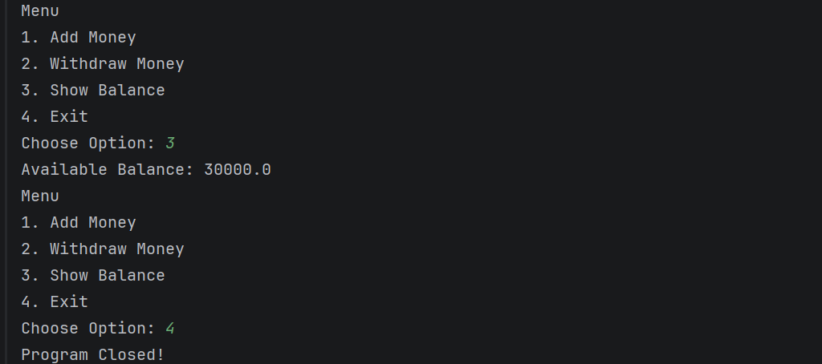
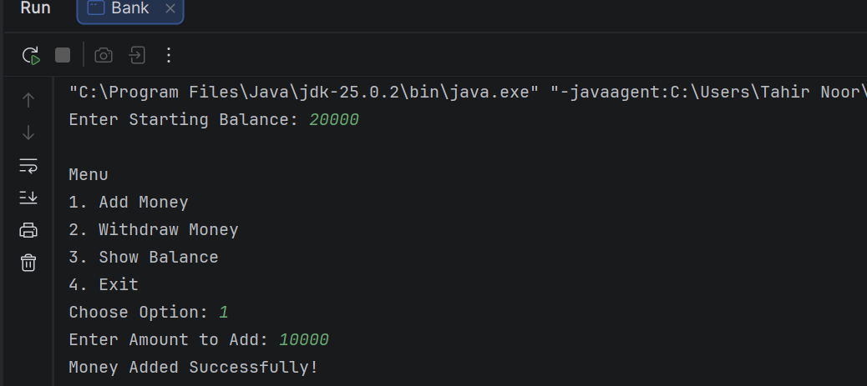
LAB 8
Task a:
Create a student class and implements it with another class.
interface Student2
{
void name();
void rollNo();
}
class StudentData implements Student2
{
public void name()
{
System.out.println("Name:Tahir");
}
public void rollNo()
{
System.out.println("Roll NO:12");
}
}
public class Student1 {
public static void main(String[] args)
{
StudentData s = new StudentData();
s.name();
s.rollNo();
}
}
OutPut:
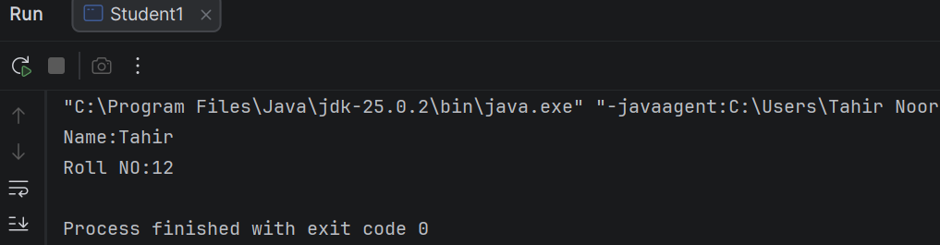

Task b:
Create an interface Teacher and implements it with another class.
interface Teacher
{
void teacherName();
void courseName();
}
class TeacherData implements Teacher
{
public void teacherName()
{
System.out.println("Teacher Name:Mubashar");
}
public void courseName()
{
System.out.println("Course:OOP");
}
}
public class Teacher1
{
public static void main(String[] args) {
Teacher t = new TeacherData();
t.teacherName();
t.courseName();
}
}
OutPut:
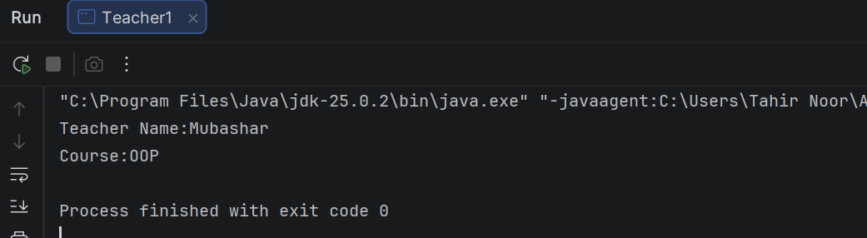

Task c:
Create a student class and extends it with another student class.
abstract class Student4
{
abstract void name();
abstract void rollNo();
}
class Studentdata extends Student4
{
void name()
{
System.out.println("Name:Tahir");
}
void rollNo()
{
System.out.println("Roll No:12");
}
}
public class Student_abstract {
public static void main(String[] args)
{
StudentData s = new StudentData();
s.name();
s.rollNo();
}
}
OutPut:
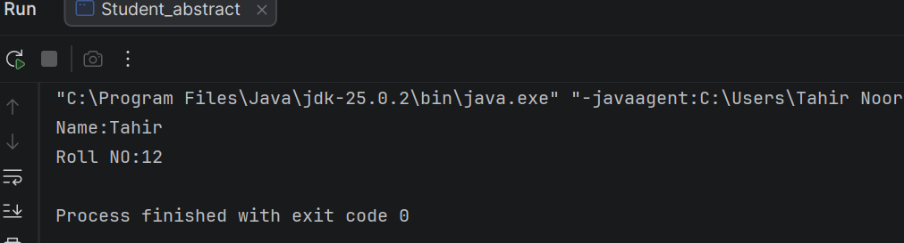

LAB 9
Task a:
Create a animal class and extends it with a dog class.
public class Animal1
{
void sound() {
System.out.println("Animal makkes a sound");
}
public static void main(String[] args) {
Dog d = new Dog();
d.sound();
d.bark();
}
}
class Dog extends Animal1 {

void bark() {
System.out.println("Dog barks");
}
}
OutPut:

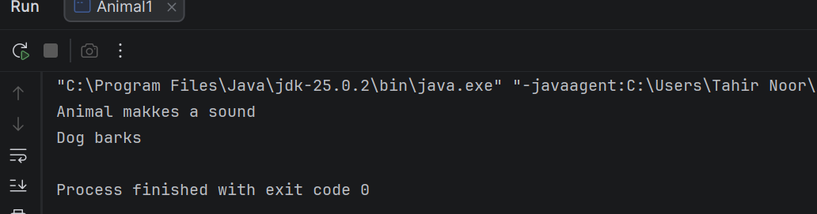

Task b:
Create a class Mobile phone and implement it with GPS and Microphone and extends with camera and media player.
interface GPS
{
void location();
}
interface Microphone
{
void recording();
}
abstract class Camera
{
abstract void picture();
abstract void video();
}
abstract class MediaPlayer
{
abstract void playAudio();
abstract void playVideo();
}
class Mobile extends Camera implements GPS, Microphone
{
void picture()
{
System.out.println("Taking Picture");
}
void video()
{
System.out.println("Recording Video");
}
public void location()
{
System.out.println("Showing Current Location");
}
public void recording()
{
System.out.println("Recording Voice");
}
}
class Media extends MediaPlayer
{
void playAudio()
{
System.out.println("Playing Audio");
}
void playVideo()
{
System.out.println("Playing Video");
}
}
public class Smart_Mobile
{
public static void main(String[] args)
{
Mobile m = new Mobile();
m.picture();
m.video();
m.location();
m.recording();
Media mp = new Media();
mp.playAudio();
mp.playVideo();
}
}
OutPut:
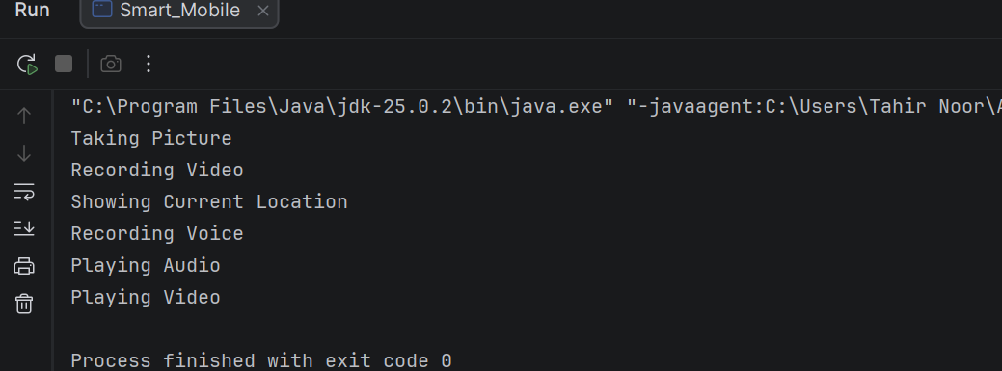

LAB 10

Task a:
Create a class Owner and extends it with a dog class.
public class Owner {
String name;
int age;
void display() {
System.out.println(name);
System.out.println(age);
}
public static void main(String[] args) {
dog1 d = new dog1();
d.showdog1();
}
}
class dog1 {
void showdog1()
{
System.out.println("dog");
System.out.println(5);
Owner o = new Owner();
o.name = "Tahir";
o.age = 19;
o.display();
}
}
OutPut:
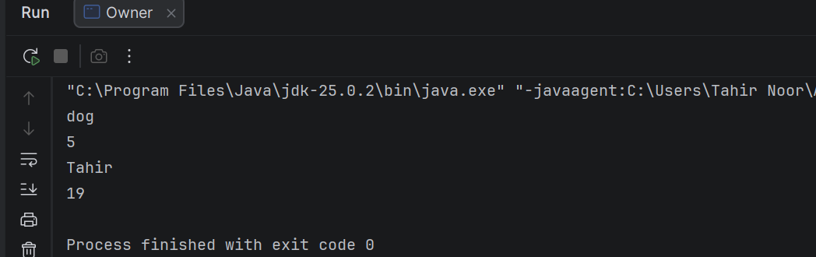

Task b:
GUI in Java.
import javax.swing.*;

public class Frame
{
public static void main(String[] args) {
int width =600;
int height = 400;

JFrame f = new JFrame();
f.setLayout(null);
f.setTitle("OOP LAB");
f.setSize(width, height);
f.setDefaultCloseOperation(JFrame.EXIT_ON_CLOSE);
f.setLocationRelativeTo(null);
f.setVisible(true);

JLabel l = new JLabel("OOP last lecture");
l.setBounds(10, 10, 250, 20);
f.add(l);

}
}
OutPut:

